GreatStack
https://youtu.be/6wf5dIrryoQ?si=-vQoHX-tGm7iDSKk
https://greatstack.dev/
What is Hooks
hooks are special function , that allow us to use state and other react feature in functional components.
Earlier . when we used to create react app using functional component , then we did not have
access to the state management and life cycle methods.
SO this was the problem with functional component.
but after introducing react hooks from version 16.8, we can now use state management and other react features without writing class components .

in other words, hooks are the functions that make functional components work like class components .
hooks made react functional components so easy to use.
developer prefer functional components over class component.

Benefits of react hooks
react hooks simplify the code, improve the readability,
useability and overall performance of the application.
So this was the problem with functional component
Types of hooks
- useState
- useEffect
- useRef, useForward ref
- useMemo
- useCallback
- useContext*
- useReducer
- useLayoutEffect
- custom hook – we can also create our own custom hooks in react js
UseState
Use State is a react hook, which create an “state variable”.
which helps us to track state in component & updates the user interface
when state changes.
example
function App() {
let color = "red";
const changeColor = () => {
color = "blue";
console.log(color);
};
return (
<div>
<h2>My favrate color is {color}</h2>
<button onClick={changeColor}>button</button>
</div>
);
}
export default App;
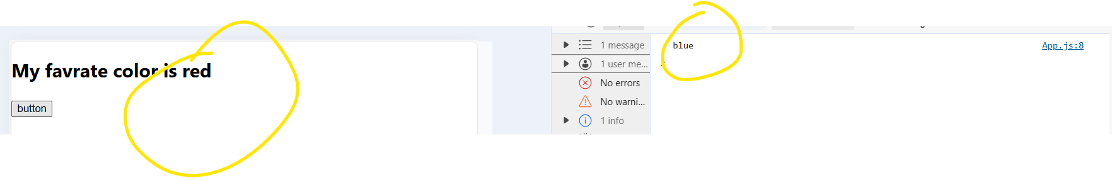

If we click on button value is not changing ,
value is getting updated in console , but it is not updating the UI
for that we have to use use state hook.
To solve this problem with useState.
example refer

Syntax
const [color, setColor] = useStare(‘red’);
updating the state using setter function
example:

function StateExampleTwo() {
const [color, setColor] = useState("Red");
const changeColor = () => {
setColor("Blue");
console.log(color);
};
return (
<div>
<h1>UseState</h1>
<h2>My favrate color is {color}</h2>
<button onClick={changeColor}>button</button>
</div>
);
}
export default StateExampleTwo;
create multiple state variable
intials value of as an object
Updating string in State
Updating number in State
Updating Arrays in State
Updating object in State

Updating object in State
Spread the previous data and updating the name value means updating the state based on previous state.
Spread the previous value and add the new data that we want to update.
Example :
function StateExampleThree() {
const [car, setCar] = useState({
brand: "farari",
model: "Roma",
color: "red",
year: 2023
});

const changeColor = () => {
setCar((pre) => {
return { ...pre, color: "blue" };
});
};
return (
<div>
<h1 style={{ color: "red" }}>
Updating the State of the Object Based on Previous State
</h1>
<h2>
It is a {car.brand} {car.model} {car.color} {car.year}
</h2>
<button onClick={changeColor}>button</button>
</div>
);
}

export default StateExampleThree;

another example : updating the state based on previous state
using the previous value we can update the previous value

we want to update the count by 4

example 1 – increament value of count by 4 without using previous state
using this method value is not increamenting by 4
value is increament by 1 only
function StateExampleFour() {
const [count, setCount] = useState(0);

const increamentCount = () => {
setCount(count + 1);
setCount(count + 1);
setCount(count + 1);
setCount(count + 1);
console.log("count", count);
};
return (
<div>
<h5 style={{ color: "red" }}>
without using previous state increament value of count by 4
</h5>
<h2>count {count}</h2>
<button onClick={increamentCount}>increament count by 4 </button>
</div>
);
}

export default StateExampleFour;

output
without using previous state value will be increament by 1 only
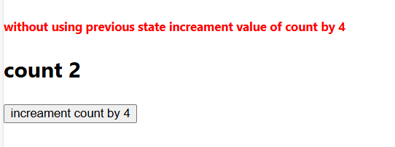
Example 2
Increament value of count by 4 using previous State
using this method value is increamenting by 4
function StateExampleFive() {
const [count, setCount] = useState(0);

const increamentCount = () => {
setCount((prev) => {
return prev + 1;
});
setCount((prev) => prev + 1);
setCount((prev) => prev + 1);
setCount((prev) => prev + 1);
console.log("count", count);
};
return (
<div>
<h5 style={{ color: "red" }}>
using previous state increament value of count by 4
</h5>
<h2>count {count}</h2>
<button onClick={increamentCount}>increament count by 4 </button>
</div>
);
}

export default StateExampleFive;
output
value will be increamented by 4
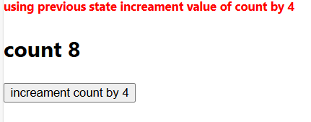
UseEffect Hooks

useEffect Hooks allow you to perform sideEffect in your component
some example of side effect are
fetching data from API
directly updating the Dom
Timers like setTimeOut and setIntervals

Import useEfect
Import React, {useEEect} from ‘react’;
Or
React.useEffect

To use the useEffect we have to provide two things ,
1. Callback function
2. dependencies

Callback function is required but dependencies is optional
If we add the dependencies , we need to add this in array []
- we can use the empty arrow also
- and we can add some variable in this array

there are three ways to use useEffect
- without any dependencies
- empty array as a dependencies
- array with variables, we can add number of variables with a comma operater

syntax
useEffect(callback function, []);

example
here we will display one counter , that will display how many times components gets loaded

it is directly going from 0 to 2, it should go 0,1, 2,3,4
to fix this issue??
function UseEffectExampleOne() {
const [count, setCount] = useState(0);

useEffect(() => {
setTimeout(() => {
setCount((prevcount) => prevcount + 1);
}, 2000);
});

return (
<div>
<h2>I have rendered {count} Times</h2>
<p>it is directly going from 0 to 2, it should go 0,1, 2,3,4</p>
</div>
);
}

export default UseEffectExampleOne;

to fix this issue??
go to index.js
this problem is happening because of React.StrictMode
React.StrictMode is additional runtime check in the development environment
To make sure your app is safe
To turn off to have to remove React.StrictMode
After that the counter will start from 0,1,2,3,4,5

Every 2 second it is increasing the value By One
Problem : here we have another problem like
We can see we have added setTimeOut, the setTimeOut execute the function only one time , so
it will increase the value by one.
but why it is increasing continuously , it is increasing the value after 2 secound,
So why it is happening,
Because we are using UseEffect without any dependency
when we use the useEffect function without any dependencies, then it will execute this
Callback function whenever any state change in this component.

We can see here we have the count state , the count state is changing in every two second,
When the count state is changing then it will again execute the callback function.

Again let understand
Here we are using useEffect without any dependencies , whenever we are using use Effect
Without any dependencies then it will execute the function ,
Whenever any state change in this component
In this component count is changing at every two second
So at every two second it will again call this function and
When this function will be executed it will increase the value by 1 at every two second.
That’s why it is continuously increasing the value by 1.example1

Example2
If we add the one dependencies , adding empty array as a dependendies
Whenever we are using empty array as a dependencies,
it will execute this callback function only once, when the component gets loaded.

it will increase the count value 1 that’s its.it is not continuously increasing it.
It will increase the count value by one only 1 time.

When we are using empty array as a dependencies, it will execute the callback function only once.
So it will execute the setTimeout only once and
It will increase the value from 0 to 1.

Callback function, component load
Callback function will execute and component will load

Render, re render the component

function UseEffectExampleTwo() {
const [count, setCount] = useState(0);

useEffect(() => {
setTimeout(() => {
setCount((prevcount) => prevcount + 1);
}, 2000);
}, []);

return (
<div>
<h2>I have rendered {count} Times</h2>
<p>it is directly going from 0 to 2, it should go 0,1, 2,3,4</p>
</div>
);
}

export default UseEffectExampleTwo;

Example3
We can use the any variable in this array,
So let me put count within the array
useEffect(() => {
setTimeout(() => {
setCount(count + 1);
console.log("inside settimeout2");
}, 2000);
console.log("inside useEffect2");
}, [count]);

It will execute the function when the component gets loaded and after that whenever this count changes it will again executes this one.
Here we are updating count by 1
So after two seconds , it will change this count value , so it will again run this one

Added conunt as a dependencies, Whenever count changes it will again execute this
Callback function.
And it will also execute the callback function when the components gets loaded first time and whenever the count changes it will again execute the fubction and

Here we can add mutiples values , multipls variables.
useEffect(() => {
setTimeout(() => {
setCount(count + 1);
console.log("inside settimeout2");
}, 2000);
console.log("inside useEffect2");
}, [count]);
function UseEffectExampleThree() {
const [count, setCount] = useState(0);
const [name, setName] = useState("monika");

useEffect(() => {
setTimeout(() => {
setCount(count + 1);
console.log("inside settimeout2");
}, 2000);
console.log("inside useEffect2");
}, [count, name]);

return (
<div>
<h5 style={{ color: "red" }}>
example three :It will execute the function when the component gets
loaded and after that whenever this count changes it will again executes
this one Here we are updating count by 1 So after two seconds , it will
change this count value , so it will again run this one.
</h5>
<h2>I have rendered {count} Times</h2>
<p>it is directly going from 0 to 2, it should go 0,1, 2,3,4</p>
</div>
);
}
export default UseEffectExampleThree;

useRef Hooks

useRef is a react hook that allow us to create mutable variables,
which will not re render the component.

when we create the variable using useRef and the variable
value changes it will not re render the component.

useRef is also used for accesing Dom element .
we can access the dom elements using the useRef hooks
and we can modify the dom elements.

Example
We will create one counter that will display
How many times our component gets re rendered .

Example:
import React, { useEffect, useState } from "react";

function UseRefExampleOne() {
const [value, setValue] = useState(0);
const [count, setCount] = useState(0);

useEffect(() => {
setCount((prevdata) => prevdata + 1);
});

return (
<div>
<h5 style={{ color: "red" }}>
example one : using useRef , Whenever the component gets render this
count value gets increase by one Whenever this count value increase by
one again re render the component. Because whenever the count gets
updated , it will change the state and it will re render the component
</h5>
<button onClick={() => setValue((prev) => prev + 1)}>increament </button>
<h2>{value}</h2>
<button onClick={() => setValue((prev) => prev - 1)}>decreament </button>
<h2>{count}</h2>
</div>
);
}

export default UseRefExampleOne;

Output : screensot
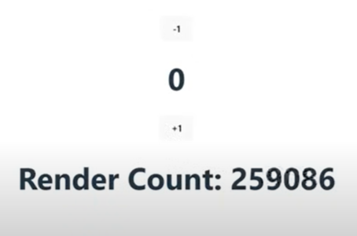

In this useeffect we are not using any dependencies,
When we use this useeffect without dependencies then this function will
Execute , whenever any state changes
We can see this couter is increasing continuously
So here we are facing one issue
This counter is increasing continuously so it will run the
counter in infinite loop
This problem is happening because use state itself causes re render.
So Whenever the component gets render this count value is gets increase
by one.
Whenever this count value gets increase by one again re render the component.
Because whenever the count gets updated , it will change the state
and it will re render the component.

That’s why this running this count till infinite.

To solve this problem we will use useRef hook
Because useref dose not re render the component when it is changed.

Example
const count = useRef(0); //value is zeros
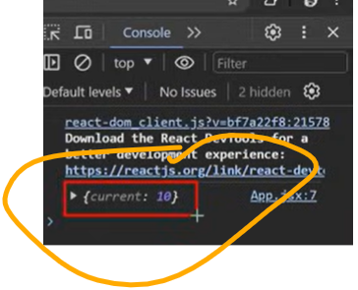

We can access the value using current properties from this object

{count.current } //0

Now We have added the count value zero, now it will increase the counter
whenever the component gets re render.

Example :
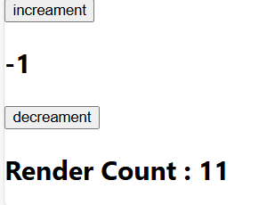
now the render count is zero, ( when we first time load the component) .
when we can click on increament , decreament button ,
according to that render count change (render count show , the number of time is our component is rendered).
Now this counter is working properly.
because useRef is not re rendering the component,
Whenever this count is changing.

But instead of this useRef if we use useState , then this count value will be changed and when the count value will be changed,
It will re render the component .
That’s why we use useRef hook,
When we do not want to re render the component.
when the value is changed.

Example
import React, { useEffect, useState, useRef } from "react";

function UseRefExampleTwo() {
const [value, setValue] = useState(0);
const count = useRef(0);
console.log(count);
useEffect(() => {
count.current = count.current + 1;
});

return (
<div>
<h5 style={{ color: "red" }}>
example Two : using useRef , Whenever the component gets render this
count value gets increase by one Whenever this count value increase by
one again re render the component. Because whenever the count gets
updated , it will change the state and it will re render the component
</h5>

<button onClick={() => setValue((prev) => prev + 1)}>increament </button>
<h2>{value}</h2>
<button onClick={() => setValue((prev) => prev - 1)}>decreament </button>
<h2>Render Count : {count.current}</h2>
</div>
);
}

export default UseRefExampleTwo;

Now we will learn about another way of using useRef hooks
That is accessing the DOM element
const inputElement = useRef();

const btnClicked = () => {
console.log(inputElement);
};
<input type="text" ref={inputElement}></input>
<button onClick={btnClicked}>Click Hre</button>

If we click on button we will get below
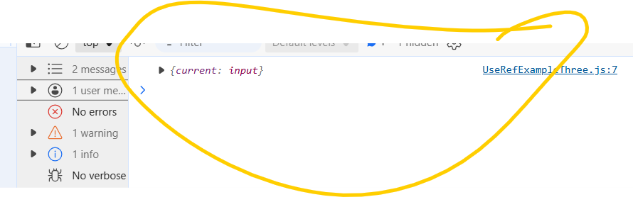
inputElement.current

Output : we will get html elements
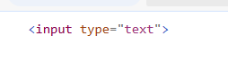
Example
const inputElement = useRef();
const btnClicked = () => {
console.log(inputElement.current);
inputElement.current.style.background = "blue";
};

<input type="text" ref={inputElement}></input>
<button onClick={btnClicked}>Click Hre</button>

If we click on submit button
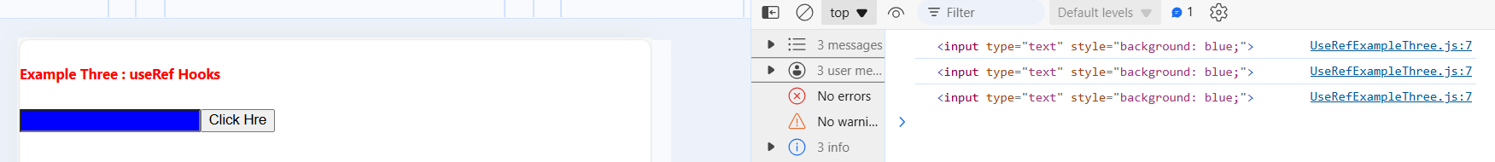
like this we can use Dom Element to select the dom element and modify the dom element.

UseMemo Hook

The react useMemo hook returns a memorized value.
(its like caching a value so that it dose not need to be recalculated).
The usememo hook only runs when one of its dependencies
gets updated.
this can improve the performance of the application.
there is one more hook in react to improve performance ,
that is useCallback hook.
the usememo and usecallback hooks are similar.
the main difference is
usememo returns a memoized value
usecallback returns a memoized function.
why we need usememo
example :
import React, { useEffect, useState } from "react";

function UseMemofExampleOne() {
const [number, setNumber] = useState(0);
const [counter, setCounter] = useState(0);

function cubeNum(num) {
console.log("Calculatio Done");
return Math.pow(num, 3);
}

const result = cubeNum(number);

return (
<div>
<h5 style={{ color: "red" }}>example one : UseMemo Hook , </h5>
<input
type="text"
value={number}
onChange={(e) => setNumber(e.target.value)}
/>
<h2>Cub of the number : {result}</h2>
<br></br>
<button
onClick={() => {
setCounter(counter + 1);
}}
>
Counter ++
</button>
<h2> Counter : {counter}</h2>
</div>
);
}
export default UseMemofExampleOne;
this calculation done message is coming from the cube function,
if we click on counter, the counter is increasing , it is also executing the calculation function.
that why we are getting this message calculation done,
this calculation done message is coming from here,
that is written in this cube function.
we have added calculation done.
here we are not updating number in this input field
but it is still calculating this cube.
because when we update this counter, it changes the state and
and it re render the web pages(component).
when the web page re render
it is recalculating this cube using this function
so prevent this function, to recalculate the cube
we can use useMemo hooks.
so lets solve this problem with useMemo hooks
import useMemo from ‘react’
useMemo :
useMemo accept two parameter
1. Callback function
2. Dependencies
example
const result = useMemo(() => {
return cubeNum(number);
}, [number]);

Or we can write like this also
const result = useMemo(() => cubeNum(number), [number]);

When the component gets re render it will not execute this function ,
It will only execute this cube number function , when this number gets changed,
If we click on counter, counter is increasing but it is not re rendering the function.
if I add any number in this field, it will return the message.

useCallBack Hooks

usecallback is a react hook that lets you cache a function definition
between re renders.

It means when we use the useCallback hook, it dose not create multiple
instance of the function when re-render happens.

Instead of creating new instance of the function, it provides the cached function
on re-render of the component.

Why we need useCallback hooks

Example :
Src/Component/Header.jsx
useCallBackBack.jsx

we can see I am updating this counter, we are not updating anything from the
header component , but still header is getting render multiple times.
Because when we are updating the counter, it is rendering the app component ,
and in this app componenent we have mounted this header Component
That’s why it is re rendering the Header Component also.
To fix this issue we will use the Memo Method
That comes under the react js package.
Usecallbackexample.jsx
function UseCallBackExampleOne() {
const [count, setCount] = useState(0);
return (
<div className="container">
<h5 style={{ color: "red" }}>example one : UseCallBack Hook , </h5>
<Header />
<button onClick={() => setCount((prev) => prev + 1)}>Click Here</button>
<h2> {count}</h2>
</div>
);
}
export default UseCallBackExampleOne;

Src/Component/Header.jsx
import React from 'react'
function Header() {
console.log("Header Component");
return (
<div>
<h1>Header</h1>
</div>
)
}
export default Header
To fix this issue we will use the Memo Method
That comes under the react js package.
Example – UseMemo Hooks
from the react we can use the Memo Method
in this export statement
export default React.memo(Header);

we can see Header rendered for one time, now if we click on the button
it will increase the counter , the counter is increasing , but it is not re rendering the header,
we can see header is re rendered only one time.
so this problem got fixed ,

what we are adding here :
Example –
function UseCallBackExampleOne() {
const [count, setCount] = useState(0);

const newFunc = () => {};

return (
<div className="container">
<h5 style={{ color: "red" }}>example one : UseCallBack Hook , </h5>
<Header newFunc = newFunc />
<button onClick={() => setCount((prev) => prev + 1)}>Click Here</button>
<h2> {count}</h2>
</div>
);
}
export default UseCallBackExampleOne;
we have created one function, using this arrow function
and then we are passing this function as a props in this header
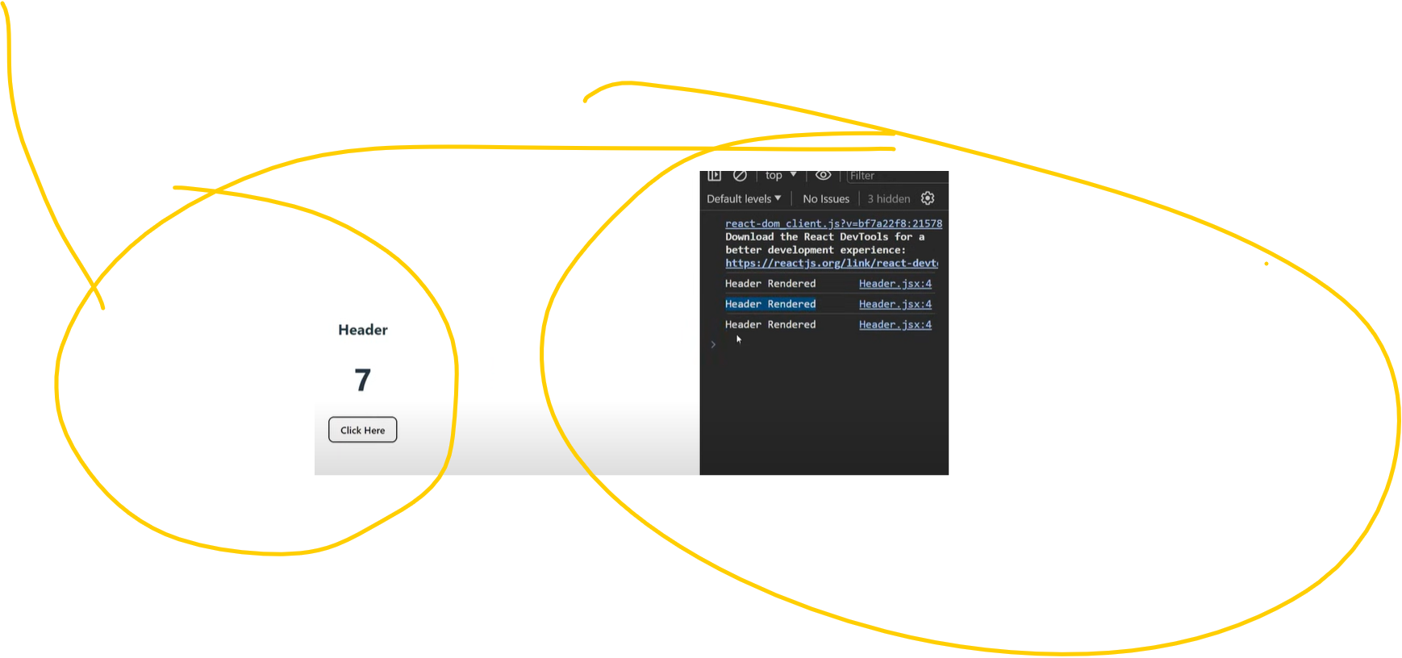
we can see – when we are updating the counter , it is again re re rendering the header component
which is not required because, because we are not changing anything in the header.

We are just passing the function, and this is the same function.
why this is happening ,
this is happening because of the referential equality

referential equality – example - console – lets declare a function
we have two function f1 is terurning the message hello
and f2 function is also returning the message hello

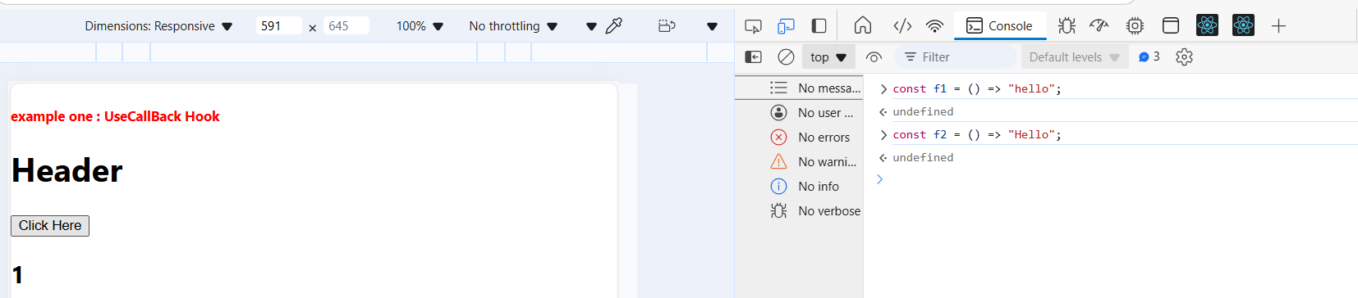
now we have two function f1 is returning one message hello and f2 is also
returning the message hello
Now comparing the function using the equality check
f1 === f2, it is displaying false

It is displaying false
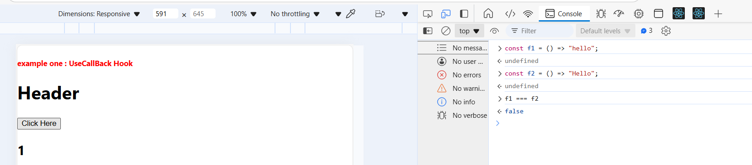

So why it is displaying false
here we have created two function f1 and f2,
both function have been created on different memory location.

It is not the same function, it is the different function , that why it is giving false

In the same way when we re render this component ,
It creates new instance of this function.
and when we are mounting this header component and providing this new function as a props
So every time we are passing a new function
So when the props is changing.
That’s why this header component is re re-rendering again.

Explaination Again
When we re render this app component
Why this app componemnt is getting re render because we click on this button
That will update this count and when this state is changing , it will re render the app component

When this app component is re rendering
It will again create the new instance of this function
Here in this app component we are mounting the header component
And in this header component on every render we are passing new function , that will be different.
Every time we are passing new function.

It means the props is changing , so whenever the props are changing then this header component will re render again .

Now we can solve this using useCallback hooks
how to implement useCallback hook
import useCallBack from react
in useCallBack hook we have to provide two parameter
1. One function
2.One dependency

Const newFunc = useCallBack(() => {}, []);
This useCallback will not create another function
It will use the cached function.

Whenever it will create this function () => {} , first time and it will catch that function () => {}
In the memory and whenever the re render happens, it will use that cached function ,
So the function will be same and when the function will be same ,
So this header props will be same ,
There will be no changes in this header props

So when the props is not changing then header will not re render again.

Const newFunc = useCallBack(() => {}, []);

We can see counter is increasing , it means the state is changing.
And header text is displayed here ,
But this header is displayed only once.

It is not re rendering , so we have fixed this problem using
the useCallback hooks
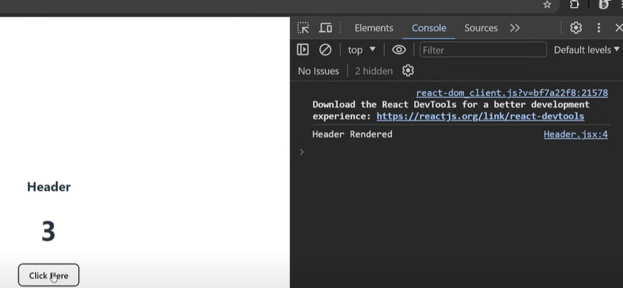
-
When this useCallback will create the new function
in this case we have to provide any dependency here

Const newFunc = useCallBack((count) => {}, [count]);
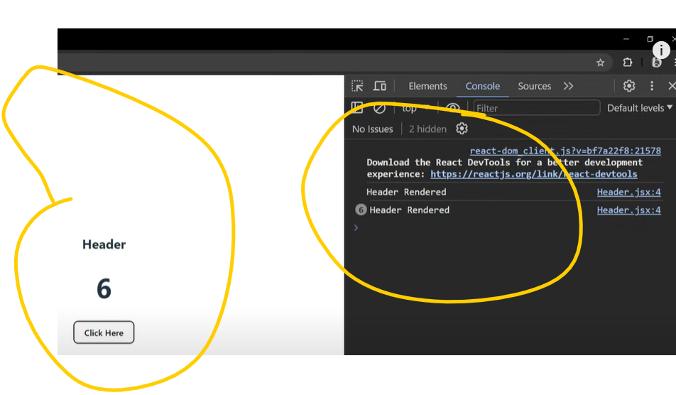

Whenever we click on the button, this count is changing , so whenever the count will change
It will create the new function
Because this count is changing, so it will create a new function .

So the new function will be passed in this header
<Header newFunct={newFun} />

So every time it will pass the new function means props will be changed in this header
So header will be re rendered again

Lets test it
We can see the re rendering is happening , here it is increasing the value
re rendering is happening because we have added the count
so whenever this dependency is changing it is creating new function and when
we remove this dependency it will not create a new function
it will use the cached function.
so the function will be same and this props will be same and
so it will prevent this header component for un necessary re render
so this is how we can use UseCallBack Hook – to store the function in cache memory.
example :
import React from 'react'

function Header() {
console.log("Header Component");
return (
<div>
<h1>Header</h1>
</div>
)
}
export default React.memo(Header);

example :
import React, { useCallback, useEffect, useState } from "react";
import Header from "../component/Header";
function UseCallBackExampleOne() {
const [count, setCount] = useState(0);
const newFun = useCallback(() => {}, []);
return (
<>
<h5 style={{ color: "red" }}>example one :::: UseCallBack Hook </h5>
<Header newFunct={newFun} />
<button onClick={() => setCount((prev) => prev + 1)}>Click Here</button>
<h2> {count}</h2>
</>
);
}
export default UseCallBackExampleOne;
useContext Hook
useContext is a React Hook that allows you
access data from any component without explicitly passing it down through props at every level.
useContext is used to manage global data in the react app.
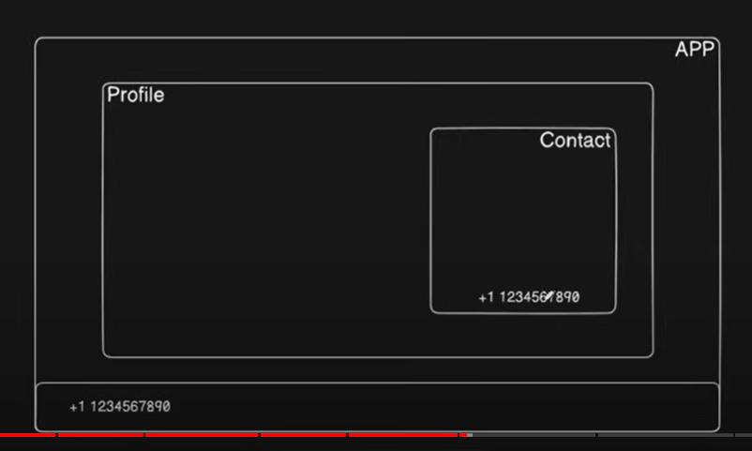
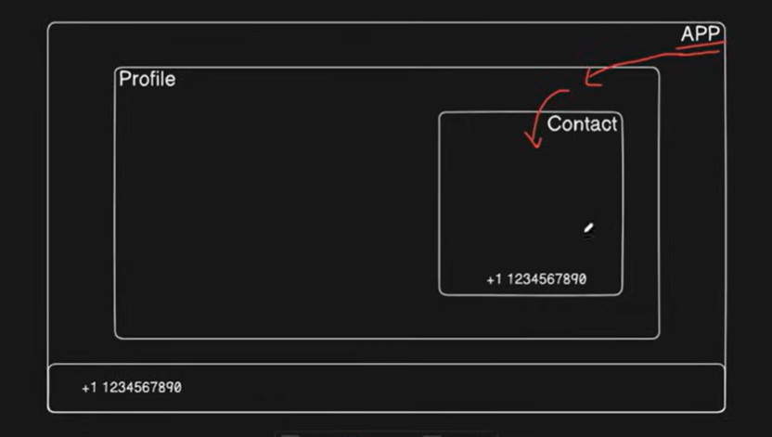

App
||
Profile / Contact
example :
useContext allow us to create global data and we can access this data from
Any components.
Without passing it through props , at every component level

We can use the useContext hook in three simple steps
1.creating the context
2.providing the context
3.consuming the context

Creating a context
context/ContextProvider.jsx
Component/Profile.jsx

context/ContextProvider.jsx

import React, {createContext} from 'react';
export const AppContext = createContext();
function ContextProvider(props) {
const phone = "+98 98 8766576";
const name = "Monika Dewangan";
return (
<AppContext.Provider value = {{phone, name}} >
{props.children}
</AppContext.Provider>
)
}
export default ContextProvider;
Component/Profile.jsx
import React, { useContext } from 'react';
import { AppContext } from '../context/ContextProvider';
function Profile() {
const {phone, name } = useContext(AppContext);
return (
<div>
<h1>Profile</h1>
<h1>{phone}</h1>
<h1>{name }</h1>
</div>
)
}
export default Profile;

main file – index.jsx
<ContextProvider>
<App />
</ContextProvider>

This Context Api can be used to share any type of data including object, function and array

UseReducer Hook – read just for knoledge
useReducer is similar to useState, but instead of providing state
and setter function .
It Provides state and dispatch function.
The useReducer hook accept two arguments
reducer function
Initial state
And return : current state and dispatch method

The Reducer function specifies how the state gets updated,
Import useReducer from react
Example
import React, { useReducer } from "react";

function App() {
const intialState = { count: 0 };

const reducer = (state, action) => {
switch (action.type) {
case "increase": {
return { count: state.count + 1 };
}

case "decrease": {
return { count: state.count - 1 };
}

case "input": {
return { count: action.payload };
}
default: {
return state;
}
}
};
const [state, dispatch] = useReducer(reducer, intialState);
return (
<div>
<h1>Use Context Hooks</h1>
<h1>{state.count}</h1>
<button onClick={() => dispatch({ type: "increase" })}>Increament</button>
<button onClick={() => dispatch({ type: "decrease" })}>Decreament</button>
<br></br>
<input
type="number"
value={state.count}
onChange={(e) =>
dispatch({ type: "input", payload: Number(e.target.value) })
}
/>
</div>
);
}
export default App;

UseLayoutEffect Hooks

useLayoutEffect works similarly to useEffect ,
but it is called before the user interface gets mounted.

useEffect gets called after printing the DOM elements .
useLayoutEffect gest called before printing the DOM element.
Dom element for example - <h2> test message </h2>
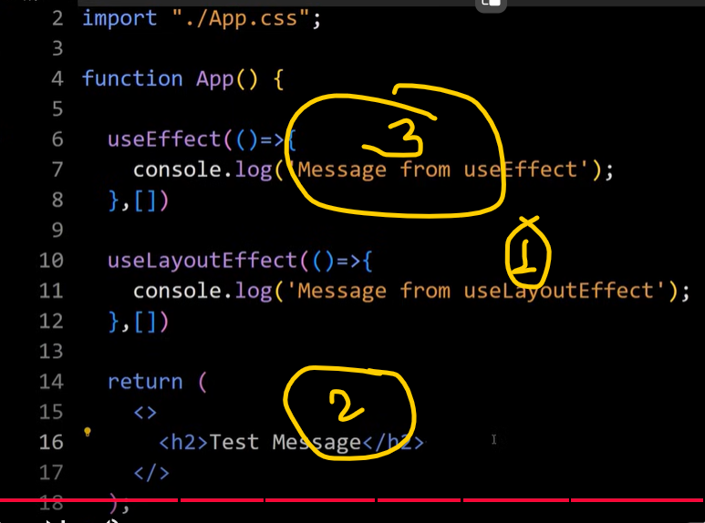
example
if we create layout using DOM elements and want to change the layout color
using the useEffect hook then , it first display the dom elements,
and after that it will change its color.
that will cause a blink or flickring issue
But when we change the color using useLayoutEffect then first it will change
the color and after that it will display the dom element on the web page.

Example :

useLayoutEffect executes the before the useEffect hook
and this uselayout effect actually executed before printing
the this h2 : <h2>test message </h2>
First it is calling this useLayoutEffect , after that it will print this dom element
Which is h2 , after that it will execute useEffect

Because this useLayoutEffect calling before mounting this UI Element
And this useEffect called after mounting this UI element.

Explanation:
useLayoutEffect is called before rendering the UI element
and useEffect is called after rendering the UI element.

We can use the useLayout hook for majoring dom elements
and for animating the elements .
and for fixing the flickring issue .
and we can also use it for api calling.

Uselayout Effect can hurt the performance of the app that’s why better to use useEffect hooks…

Example
import React, { useReducer, useEffect, useLayoutEffect } from "react
function UseLayoutEffectExample() {
useEffect(() => {
console.log("message from useEffect Hook");
}, []);
useLayoutEffect(() => {
console.log("message from useLayoutEffect Hook");
}, []);

return (
<div>
<h2>Test Message </h2>

{Array(4000)
.fill("")
.map((item, index) => (
<li key={index}>{Math.pow(Math.random(), 10)}</li>
))}
</div>
);
}
export default UseLayoutEffectExample;
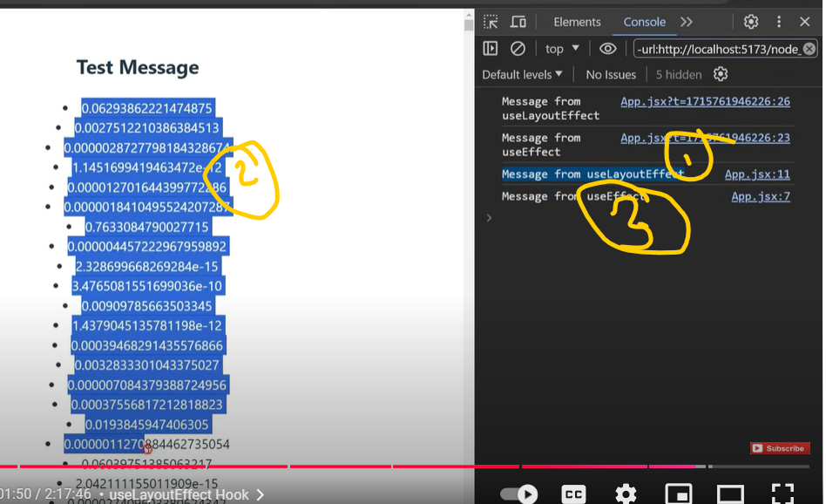

Custom Hooks
https://dev.to/rasaf_ibrahim/a-guide-to-react-custom-hooks-2b4h

Yoshita jain
https://youtu.be/Vs43P8zcRr4?si=m1bEGcn2PtxRZeXE

build in hooks like
useState hooks, useEffect hooks, useRef hooks, useCallback hooks
useMemo Hooks

a custom hook is a Javascript function whose name starts with “use”
we can use other hooks in custom hooks as well.
why to use custom hook
to remove the duplicate logic in components and we can extract that
logic to custom hook.

Custom hook - means hum chahe to apna khud ka ek hook bna skte hai
According to our requirement.
To usse hum khte hai , custom hooks
To it means , mujhe apne hisab se kisi hook ko customise krna hai it means
Mujhe apne according koi hook bnana hai , create krna hai , to wo kahlata hai hamara custom hooks.

Custom hooks hote kya hai,
custom hook hamare javascript ke functions hote hai jinka name hamesha use keywords se start hota hai,
It means mai apne hooks ka name kuch bhi rkh skte hai, bas uska name use se start hona
chahiye.

Example
useABCD, useCounter
Hooks ki pahchan yahi hai ki use se start hota hai

Esliye jab bhi hum khud ka hook bnate hai to hume , yahi conventional follow krna chahiye..
Ki hum us hook ka name hame use keywords se start Kare,

And second important thing about custom hook is hum apne custom hook ke undar build in hook bhi use kr skte hai.

Why we use custom hooks
Hamare pass two or two se jyada component aise ho jate hai ,
jisme hum similar kind of logic likhte hai

It is not a good practice to write similar kind of code again and again

And ye use na krke hum higher order function ka bhi use kar skte hai
Ya phir custom hook ka bhi use kar skte hai

Custom hook , javascript function ki tarah hote hai,
jaise hum javascript function ko ek nahi bar bar call kr skte hai
And hume usse define sirf ek hi bar krna hota hai

Esi tarike se hum custom hook me share logic likh skte hai
Or jiss bhi component me hume us logic ki jarurat hai , hum apne custom hook ko wapas
Waha par call kar skte haii

Custom hook - - to remove duplicate login in our components
We can extract that logic to the custom hook

App.js
Import react from ‘react’;
Function App () {
const [count, setCount] = useState(0);

Function Increament () {
setCount(prev => prev+1)
}

Function Decreament () {
setCount(prev => prev - 1)
}

return (
<>
<h1>custom hook</h1>
<h2>{count}</h2>
<button onClick = {increament}>increament</button>
<button onClick = {decreament}>increament</button>

</>
)
}

Outlook :
Simple increament and decreament functionality will work

Suppose hamare pass aisa hi ek component hai ,
usme condition ye hai ki hamare initial value jo hai o nah o ke 10 honi chahiye
const [count, setCount] = useState(0);
to us case me mai kyu alag se apna component bnau
to us case me hum kya kr skte hai ,
to us case me hum apna custom hook bna skte hai
or uske undar sari functionality likh skti hu

or jis tarike se yha parr useState ko call kiya hai
usi tarike se custom hook ko baki component me use kar skte hai

ab hum esi example ko kis tarike se custom hook me bna skte hai

useCounter.jsx
import react from ‘react’

function useCounter (){
const [count, setCount] = useState(0);

function Increament(){
setCount(count+1)
}

function Decreament(){
setCount(count+1)

return [count, Increament, Decreament]
}
export default useCounter;

App.js
jis tarike se hum usestate ko import and repeat krte hai
or wo hook hume two value ko return krta hai

function counter1(){
const [count, increament, decreament] = useCounter();
return (
<div>{count}</div>
<button onClick = {increament}> increament </button>
<button onClick = {decreament}>decreament </button>
)
}

function counter2(){
const [count, increament, decreament] = useCounter(20);
return (
<div>{count}</div>
<button onClick = {increament}> increament </button>
<button onClick = {decreament}>decreament </button>
)
}
//we can change initial value here

Best example –

Types of custom hooks
https://dev.to/arafat4693/15-useful-react-custom-hooks-that-you-can-use-in-any-project-2ll8#:~:text=useFetch%20is%20a%20custom%20React,%2C%20error%2C%20and%20value%20states.

React allows us to create our own hook which is known as
custom hook.
So why we create a custom hook.

Lets suppose we have a component logic that need to be used by multiple component
So we can extract that logic to create a custom hooks.

Example-
Here in this app component we have added one input field,
And one title in h2,
Here we are displaying hello , and the {name}.
And this name is coming from this state variable

We have name and setName and we have created it using usestate.

Here we have added the useEffect hook
To remove the duplicate logic in the component

